**Fruit Ninja**

**Project 4**

Mohamed Hany

4580

**User Guide:**

* First you have to choose either classic mode or arcade mode, classic mode will allow you to play the game in unlimited time but you have 3 lives only, while the arcade mode will allow you to play only 60 seconds with unlimited lives.
* Second you have to choose your difficulty (easy, medium or hard),it differ in speed of movement and number of fruits thrown at once.
* Then start playing the game, you have to slice the fruits only
* Apple and guavas are special fruits which will increase your score by 2.

**Design patterns:**

* **Singleton:** used in GameEngine class in order to have only one instance of it.
* **Factory:** used to generate random objects of fruits and bombs
* **Command:** used to load the best score from the files
* **Observer:** used to update the score and also to reset the game.
* **MVC**

**Snapshots:**

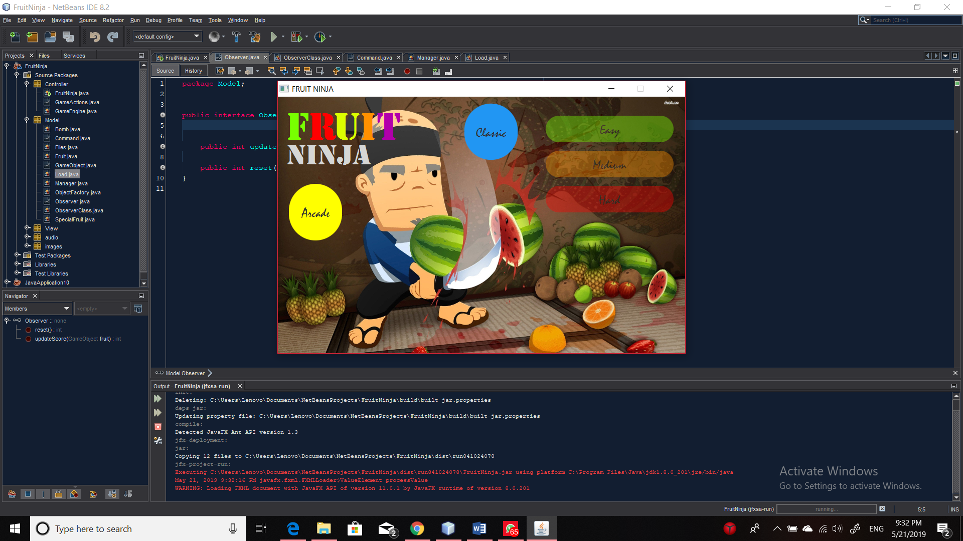

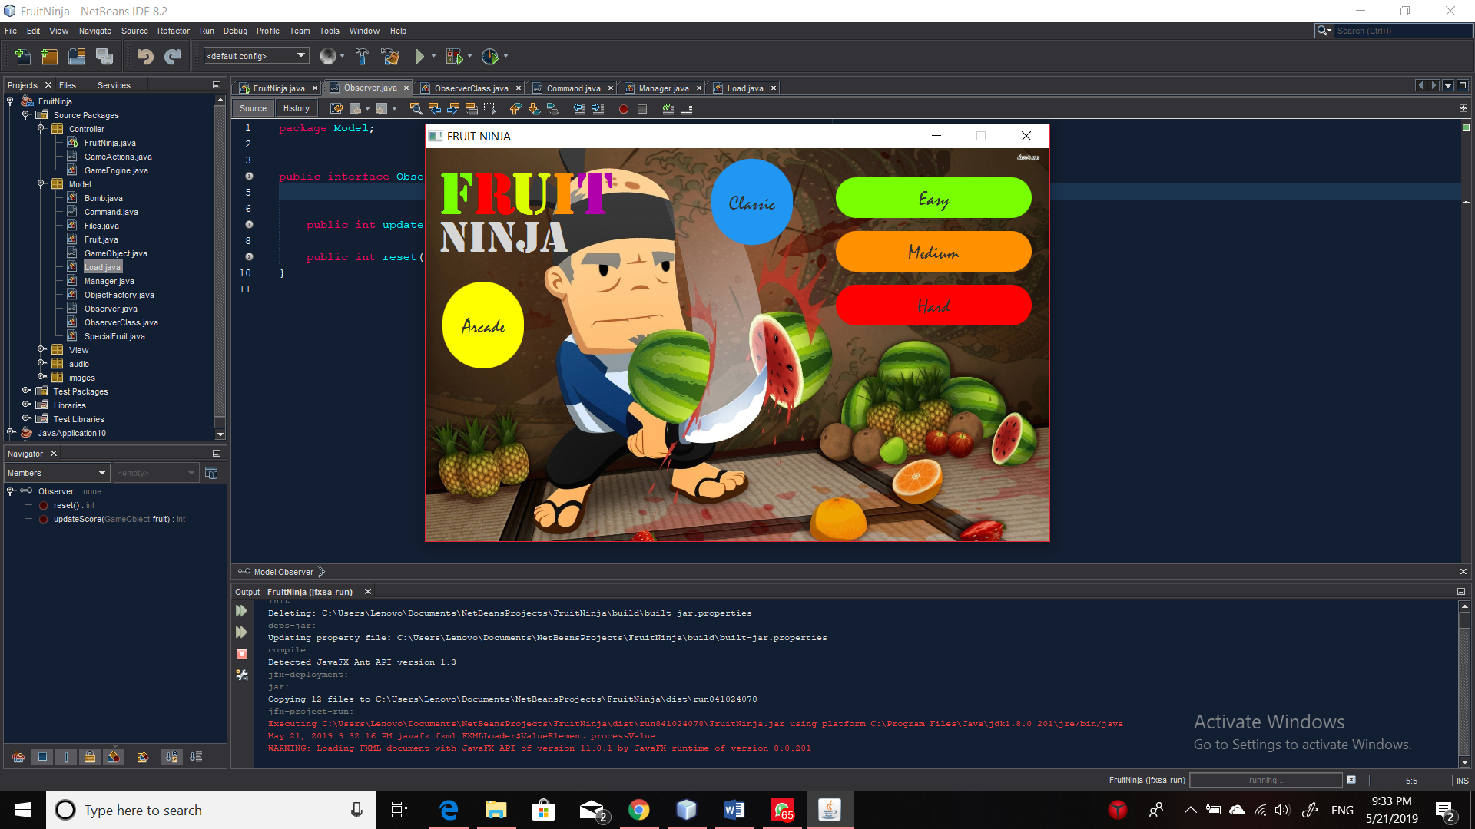

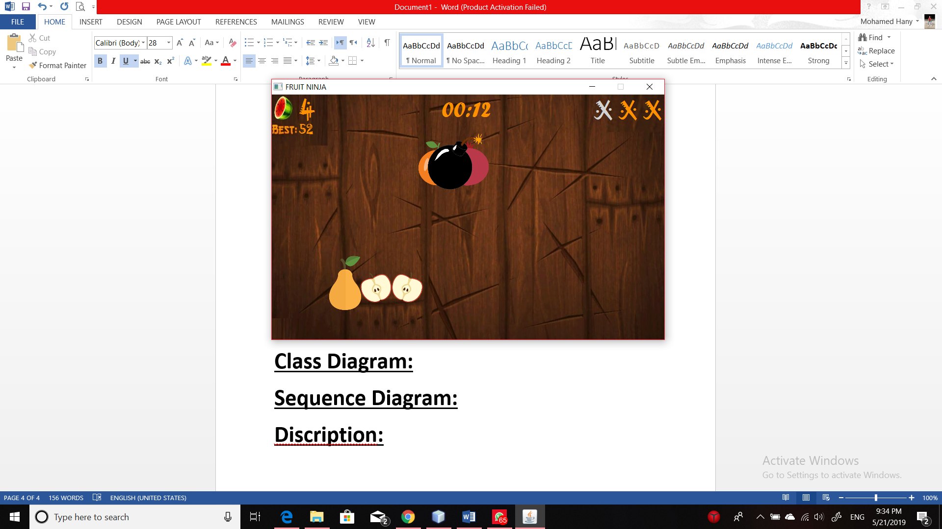

**Class Diagram:**

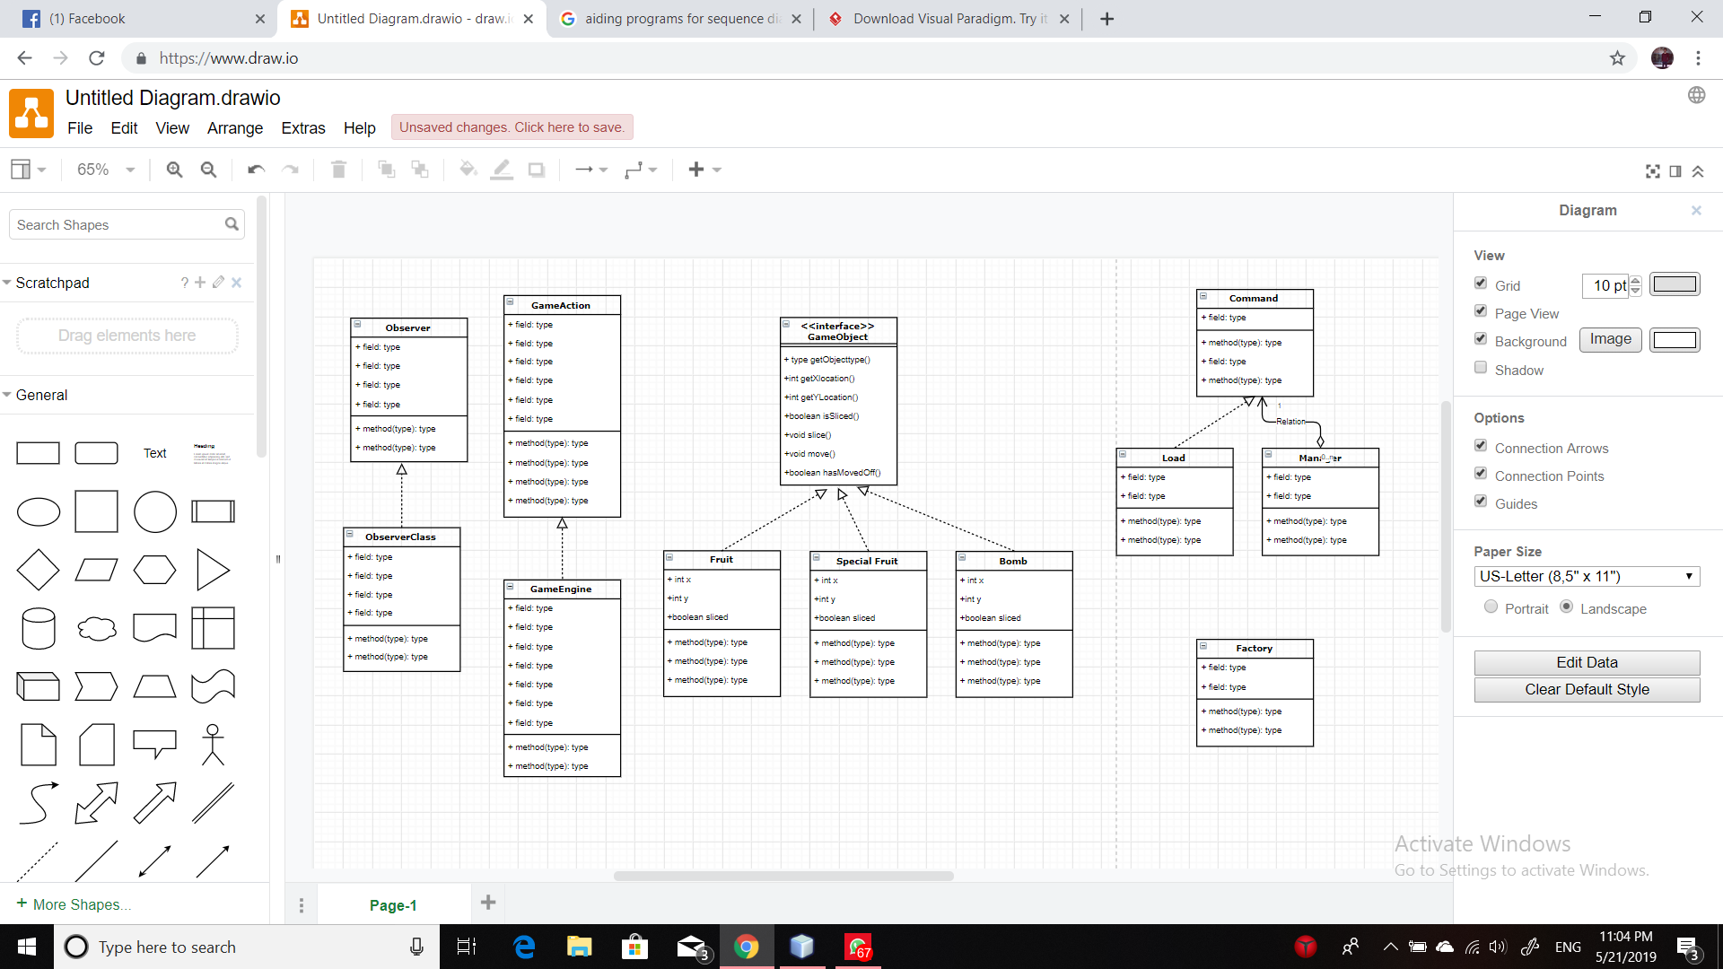

**Sequence Diagram:**